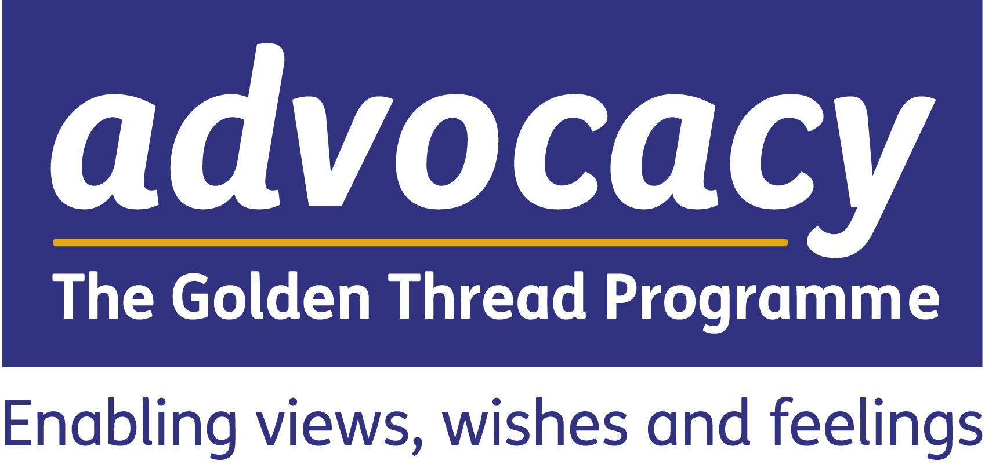
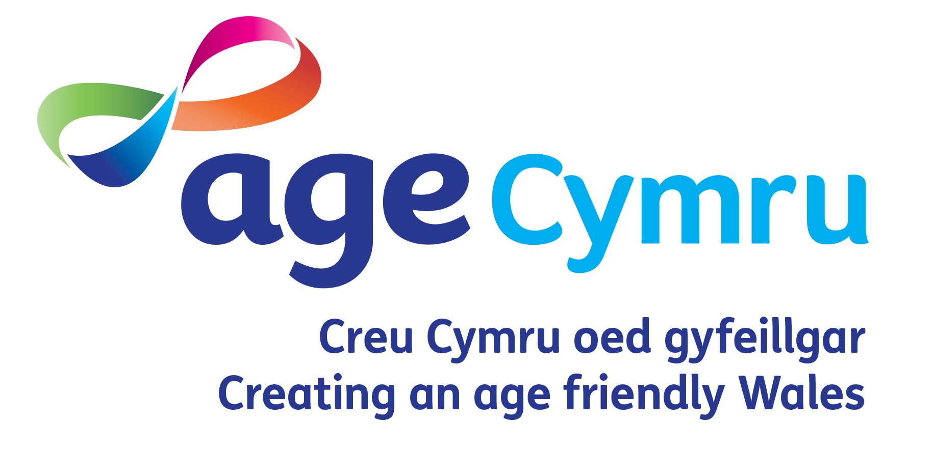

IMPLEMENTIng the code of practice on advocacy

SELF assessment Tool for commissioners

Golden Thread Advocacy Project – funded by the Welsh Government

November 2016

SELF assessment Tool · INTRODUCTION

Purpose
The purpose of this Self Assessment Tool is to ascertain organisational readiness to comply with the Part 10 Code of Practice (Advocacy) and its strategic intent.
The Self Assessment Tool itself is structured in four sections reflecting the different stages of the commissioning cycle: analyse, plan, do, review. It should be noted that this is not an audit instrument through which a ‘performance management’ assessment might be made, but rather it should help the Golden Thread Advocacy Project (GTAP) support you to achieve the aspirations of the Act.
Key points that we would like to underline:
- This tool is for you to use in an iterative way. It can be adapted and revisited as time passes
- We suggest you complete it in collaboration with your team and with partners where possible
- This tool is not designed to question you about facts and figures relating to your commissioning of advocacy services – we are interested in your professional judgement on the key statements included in the tool.
About the Golden Thread Advocacy Programme
The Golden Thread Advocacy Programme (GTAP) has been funded by Welsh Government for 3 years to run alongside and support the implementation of Part 10 (Advocacy) of the Social Services and Well-being (Wales) Act 2014.
The programme's key aims are:

- To support the commissioning of independent professional advocacy through a sustainable, strategic approach.
- To improve the availability of advocacy services to adults across Wales
- To improve the well-being of individuals through advocacy and to give them a stronger voice

This national programme will:

- Support strategic health and social care management/commissioning teams and front line professionals in understanding their responsibilities regarding advocacy under the Act.
- Support the development of sustainable models for advocacy service delivery.
- Work with new and existing service providers to ensure they are tender ready for statutory advocacy commissioning processes.
- Create a framework for collaboration between statutory bodies and service providers in using resources more efficiently to support well-being outcomes.
- Work with representative groups of potential service users and carers to raise awareness of advocacy in all its forms, in exercising control over their well-being outcomes
- Promote positive approaches to well-being and support improvements to safeguarding by giving people with protected characteristics a stronger voice.
Guide to assessment
There are challenges in ensuring that there is consistency of scoring in self-assessment exercises. We have tried to provide a structure that will ensure a standard approach to scoring as far as possible. The Table on the following page describes the assessment system.
Whenever you are making an assessment within the Tool, you are judging your own organisation's readiness to comply with a series of good practice statements regarding the commissioning of independent advocacy.
To do this, you will need to consider all the evidence currently available to enable you to make your own assessment, for example: policy statements/corporate commitments; strategic documents supporting these statements; monitoring reports providing evidence of service delivery; contracts in place; evidence of stakeholder input, etc. Once you have considered the currently available evidence, you will select which of the following four levels best matches your assessment, within the range available for that level, as below;
- Green = good evidence to suggest you comply with the good practice statement
- Yellow = sufficient evidence to suggest you comply with the good practice statement
- Amber = insufficient evidence to suggest you comply with the good practice statement
- Red = poor evidence to suggest you comply with the good practice statement

The top two of these (green and yellow) might be described as being ‘above the line’, and the other two sit below, by which we mean that if you are assessing yourselves as amber or red there is clearly much more work to be done in order to comply with the good practice statements than for assessments in the yellow or green ranges. Within each of these ranges there is also a scale which allows you to tell us where in that range you think you are (see table 1). For each good practice statement, a score should be placed in one of the boxes.
Table 1: Self-assessment scoring guide for commissioners

ASSESSMENT | RANGE OF SCORE THAT CAN BE GIVEN | WHAT THIS SCORE MEANS?
Good  Green | Between  76 and 100 | You have good evidence to suggest that you comply with the good practice statement.
Sufficient  Yellow | Between  51 and 75 | You have sufficient evidence to suggest that you comply with the good practice statement.
Insufficient  Amber | Between  26 and 50 | You have insufficient evidence to suggest that you comply with the good practice statement.
Poor  Red | Between  1 and 25 | You have poor evidence to suggest that you comply with the good practice statement.

Completing the self-assessment tool
Who should make the assessments?
This is very much down to you, but we think that discussing the statements as a team and with partners where possible, and coming to a view about them would be a good way to make the assessment.
Who will see your assessment?
In addition to the GTAP team, an anonymised version of your self-assessment will be shared with independent evaluators of the GTAP project from the Welsh Institute of Health and Social Care. No identifiable information will be shared.

To ensure clarity and transparency it is important for respondents to understand that Age Cymru's Golden Thread Advocacy Programme does not deliver front line advocacy services of any kind. It works strategically to support the implementation and aspirations of the Social Services and Well-being Wales Act only. The aim is for the information collected from this survey to support the commissioning of Independent Professional Advocacy services and not for commercial gain.
By when do you need to complete the self assessment?
We’d like if possible to receive completed self-assessments from you by Friday 9 December 2016.

Where to return your completed self assessment
Please complete this document and return it to the GTAP team via email:
goldenthreadadvocacy@agecymru.org.uk.
The profile questions do not require you to submit your name and contact details, but you can do so if you wish to be contacted by GTAP. GTAP staff are able to offer you free, flexible support for commissioning advocacy. If you would like to discuss how we may be able to support you, please ensure you leave us a means of contacting you.

SELF assessment Tool

SELF assessment Tool · GOOD PRACTICE STATEMENTS ON COMMISSIONING ADVOCACY

GOOD PRACTICE STATEMENTS |  | Your assessment of whether you have evidence to suggest you comply with the good practice statement
 |  | Poor evidence  1-25 | Insufficient evidence  26-50 | Sufficient evidence  51-75 | Good evidence  76-100
1 | ANALYSE
1a | We collect and analyse information to understand current and future demand for advocacy under the SS&W-B Act.
1b | We have a systematic process of involving local people who use, or may use, these services, in collecting and analysing this information.
1c | We know what resources we have available for commissioning advocacy services and the profile of service users most likely to require support. We can confidently project our future financial commitments.
1d | We analyse the activity and performance of existing advocacy provision in our area.
2 | PLAN
2a | We have developed a clear written strategy and agreed outcomes for the provision of advocacy in line with our duties under the SS&W-B Act that signal our future commissioning intentions.
2b | We facilitate ongoing dialogue with key stakeholders and potential providers in order to build a consensus on the implications of our plans in the local area.
2c | We have a co-productive approach to commissioning which enables local people to contribute to the design of services and maximises control over services once they are established.
GOOD PRACTICE STATEMENTS |  | Your assessment of whether you have evidence to suggest you comply with the good practice statement
 |  | Poor evidence  1-25 | Insufficient evidence  26-50 | Sufficient evidence  51-75 | Good evidence  76-100
3 | DO
3a | We have a clear picture of the range of potential providers in our area: their strengths, weaknesses and future plans.
3b | We influence the local market for advocacy to develop services in line with local needs, rather than the historical awarding of contracts.
3c | We have developed service specifications and contracts that are flexible, evidence-based, clear about requirements and outcome-focused.
4 | REVIEW
4a | We bring together relevant data on the activity, finance and outcomes of our commissioned services to judge whether they deliver value for money.
4b | We have contract monitoring processes in place that focus on developing positive and collaborative relationships with providers to improve performance.

Please use the boxes below to record any key strengths and/or areas for development identified after completing the self- assessment exercise above.

Key strengths (for green or yellow assessments)  Please indicate which good practice statement your key strength corresponds to (using the numbered list in the self –assessment tool). | Areas for development (for amber or red assessments)  Please indicate which good practice statement your area for development corresponds to (using the numbered list in the self-assessment tool).

SELF assessment Tool · PROFILE QUESTIONS

Where do you work? | Blaenau Gwent |  | Conwy |  | Monmouthshire |  | Swansea
 | Bridgend |  | Denbighshire |  | Neath Port Talbot |  | Torfaen
 | Caerphilly |  | Flintshire |  | Newport |  | Vale of Glamorgan
 | Cardiff |  | Gwynedd |  | Pembrokeshire |  | Wrexham
 | Carmarthenshire |  | Isle of Anglesey |  | Powys |  | All-Wales
 | Ceredigion |  | Merthyr Tydfil |  | Rhondda Cynon Taf |  | Other: ___________

In which sector do you work? | Local government
 | Health
 | Other: _______________

What is your role related to? | Commissioning
 | Contracting
 | Both
Other:
________________

Who do you commission for? | Children
 | Adults
 | Both

If you’d be interested in finding out more about the work of GTAP and how they might be able to support you in your role please provide an email address and contact phone number. | Name | _____________________________
 | Email | _____________________________
 | Phone | _____________________________

Self Assessment Tool prepared by:
Mark Llewellyn
Welsh Institute for Health and Social Care

University of South Wales, Lower Glyntaf Campus, Pontypridd, CF37 1DL

wihsc.southwales.ac.uk · wihsc@southwales.ac.uk · 01443 483070

© Age Cymru 2016

It builds on the work of SCIE and IPC in England who produced a similar self-assessment tool for independent advocacy – see https://www.scie.org.uk/care-act-2014/advocacy-services/commissioning-independent-advocacy/tasks/self-assessment-tool/self-assessment-tool.pdf

