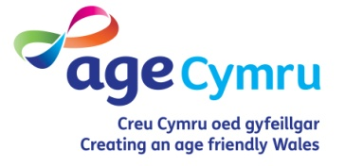

Independent Professional Advocacy and the Information, Advice & Assistance Service

Information, Advice and Assistance (IAA) and Independent Professional Advocacy (IPA) both have key roles in the new approach to care and support. Staff working in IAA services may need to refer some people to an IPA service. What process should be followed to decide when a referral should be made?

The Social Services and Well-being (Wales) Act (“the Act”) requires local authorities to consider whether an individual may have a need for Independent Professional Advocacy (IPA) at every step of their journey through the social services system, including at their first point of contact. The Part 10 Code of Practice on Advocacy (“the Code”) states:

Para 47. Local authorities must arrange for the provision of an independent professional advocate when a person can only overcome the barrier(s) to participating fully in the assessment, care and support planning, review and safeguarding processes with assistance from an appropriate individual, but there is no appropriate individual available.¹

Participating fully

The Code explains what participating fully in the assessment, care and support planning, review and safeguarding processes means:

Para 48. Participating fully enables the individual to express or have represented and taken into account their views, wishes and feelings; that they understand their rights and entitlements; the decision making process; what matters to them; the personal well-being outcomes that they wish to achieve; the barriers to achieving those outcomes, and the options and choices available to them.²

Overcoming barriers

In Chapter 12 the Code also explains “What constitutes the barriers which can impact on an individual’s ability to engage and fully participate”:

Para 55. Local authorities must in partnership with each individual, consider whether that individual is likely to experience barriers to participating fully in determining their well-being outcomes, and reach a conclusion on their needs for advocacy support. Key barriers will include issues and situations that will impair individuals’ ability to:

- understand relevant information
- retain information
- use or weigh information
- communicate their views, wishes and feelings.³

Appropriate individual

The role of the “appropriate individual” is key to understanding what type of advocacy is required in individual cases. An appropriate individual is someone who can facilitate a person’s involvement in the assessment, care planning, review and safeguarding processes, but cannot be someone who:

- the person does not want to support them
- is unlikely to be able to, or available to, adequately support them, or
- is implicated in a safeguarding enquiry.⁴

The appropriate individual may be a family member, friend, carer, or anyone providing a non-professional form of independent advocacy, as long as they meet the above criteria. Crucially, they must have sufficient understanding of local authority processes to be able to support the person’s participation in determining their well-being outcomes and obtaining the care and support they need.

If there is no appropriate individual available, the person must be referred to a statutory IPA service.

Information Advice and Assistance service (IAA)

For many people with care and support needs, IAA services will be their first point of contact with social services.⁵

The Part 2 Code of Practice (General Functions) recognises that:

Para 327. Some people will require support to be able to make initial contact. Local authorities must consider how best to support individuals to ensure that the IAA service is accessible and that appropriate assistance including advocacy is given.⁶

Thus front line staff working in IAA services have a critical role in ensuring that all individuals have access to independent advocacy if they need it. In view of this, local authorities are required to "ensure that staff within the service are suitably skilled to identify individuals who need an advocate, and that the service takes action to ensure those individuals are supported."⁷

When considering individuals’ possible need for advocacy, IAA staff are expected to follow the decision pathway shown below.⁸

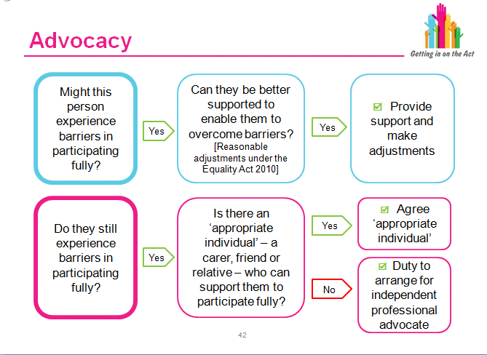

This decision making process should be followed throughout the assessment, care and support planning, safeguarding and review processes.

The Care Council's Level B Introduction and General Functions Training Module includes an in depth case study⁹ and a set of questions¹⁰ to assist practitioners in judging whether someone might be experiencing barriers and whether advocacy might be needed.

References

1. Part 10 Code of Practice (Advocacy), para 47:
http://gov.wales/docs/dhss/publications/151218part10en.pdf
2. Part 10 Code of Practice, para 48.
3. Part 10 Code of Practice, para 55.
4. Part 10 Code of Practice, para 61 and section 13.
5. How to access care and support:
http://www.ccwales.org.uk/edrms/157190/
6. Part 2 Code of Practice (General Functions), para 327:
http://gov.wales/docs/dhss/publications/151218part2en.pdf
7. Part 2 Code of Practice, para 329.
8. Introduction and General Functions Level B Training Module Powerpoint Slide 42,
http://www.ccwales.org.uk/edrms/157075/
9. Introduction and General Functions Level B Training Module Case study pp79-80:
http://www.ccwales.org.uk/edrms/157294/
10. Introduction and General Functions Level B Training Module Exercise 3.43.2 p78-79.

© Age Cymru 2016

