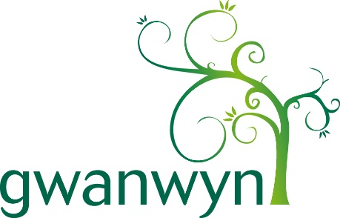

Nomination for change-maker

Your name ………………………………………………………………………

Name of person you’re nominating …………………………………………..

Please tell us the town they live in …………………………………………

Please tell us why you’re nominating them?.............................................

……………………………………………………………………………………

……………………………………………………………………………………

……………………………………………………………………………………

……………………………………………………………………………………

……………………………………………………………………………………

----------------------------------------------------------------------------------------------------------------
Age Cymru is a registered charity 1128436. Company limited by guarantee and registered in Wales and England 6837284. Registered office address Ground Floor, Mariners House, Trident Court, East Moors Road, Cardiff CF24 5TD. © Age Cymru 2024
Do you have their consent to nominate them and share their photo with us?

I have permission to nominate this person and share their image with you.

I don’t have permission to nominate this person or share their image with you.

Please be advised, we’re unable to use any submission without confirmation of consent.

Signature: ………………………………………………………………………

Print name: …………………………………………………………………….

Date: …………………………………………………………………………….

Please ensure you include their photo when submitting this application. Please note that we unfortunately cannot return any photos sent to us.

You can send your completed form and photos by email to gwanwyn@agecymru.org.uk or by post to
Age Cymru
Change Makers Project
Mariners House
Trident Court
East Moors Road
Cardiff, CF24 5TD
----------------------------------------------------------------------------------------------------------------
Age Cymru is a registered charity 1128436. Company limited by guarantee and registered in Wales and England 6837284. Registered office address Ground Floor, Mariners House, Trident Court, East Moors Road, Cardiff CF24 5TD. © Age Cymru 2024

Your nomination and their photograph/s may be used in all publicity of our change makers project. This will include national and regional newspapers and magazines, social media, website, newsletters, displays, exhibitions. Please note this list is not exhaustive.

You can withdraw consent at any time but calling us on 029 2043 1555 or emailing unsubscribe@agecymru.org.uk

----------------------------------------------------------------------------------------------------------------
Age Cymru is a registered charity 1128436. Company limited by guarantee and registered in Wales and England 6837284. Registered office address Ground Floor, Mariners House, Trident Court, East Moors Road, Cardiff CF24 5TD. © Age Cymru 2024

